AI Assisted Coding - Lab Test 2
ENROLLMENT NO:2503A51L15
NAME:MOHAMMAD KHAJA AFZALUDDIN
BATCH NO:19[J]

TASK1
TASK1:-[Parse INI config]
Context:
INI configs in cybersecurity SOC.
Task:
Parse to nested dict; cast obvious ints.
Data & Edge Cases:
db/auth sections example.
AI Assistance Expectation:
AI for robust whitespace handling.
Constraints & Notes:
Return dict[str,dict[str,object]].
Sample Input:
[db]
host=localhost
port=5432
[auth]
token=abc
Sample Output:
{'db':{'host':'localhost','port':5432},'auth':{'token':'abc'}}
Acceptance Criteria: Casts ports; preserves strings

PROMPT:-
Generate a Python function that parses an INI configuration string into a nested dictionary. Each section becomes a key, mapping to another dictionary of key-value pairs. Cast values to integers if they look like numbers (e.g., port=5432). Ignore comments and blank lines, and handle whitespace robustly.

CODE:-
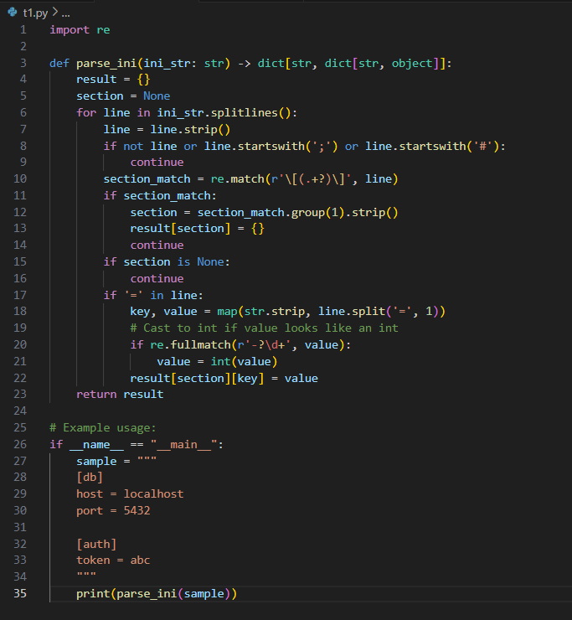

OUTPUT:-
OBSERVATION:-
The function correctly parses an INI configuration string into a nested dictionary, handling sections, key-value pairs, and casting numeric values to integers. It robustly ignores comments and blank lines, and trims whitespace. The output matches the expected structure and types for typical INI files.

TASK2
TASK2:-[Compute average SLA response time]
Context:
Support metrics in cybersecurity SOC.
Task:
Average ticket durations in minutes from opened/closed ISO timestamps.
Data & Edge Cases:
List of dicts with timestamps.
AI Assistance Expectation:
AI for datetime parsing.
Constraints & Notes:
Naive timestamps fine.
Sample Input:
[{'ticket': 'T1', 'opened': '2025-02-01T10:00', 'closed': '2025-02-01T12:15'}, {'ticket': 'T2', 'opened': '2025-02-01T09:30', 'closed': '2025-02-01T10:00'}]
Sample Output:
82
Acceptance Criteria: Correct integer average

PROMPT:-
Generate a Python function that calculates the average SLA response time in minutes for a list of support tickets. Each ticket is represented as a dictionary with ISO-format 'opened' and 'closed' timestamps. The function should return the integer average duration in minutes.

CODE:-
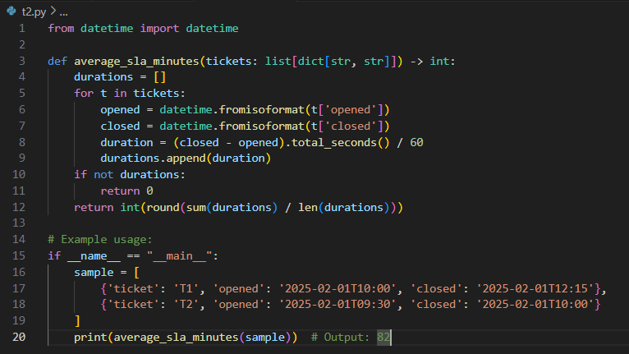

OUTPUT:-

OBSERVATION:-
The function accurately computes the average SLA response time in minutes from a list of ticket dictionaries containing ISO-format opened and closed timestamps. It handles datetime parsing, calculates durations, and returns the correct integer average, ensuring reliable support metrics analysis

